Software Requirements Specification   
–Online Shopping System

Created By: Kirubanithi V

Date: October 12, 2022

1. Abstract 3

2. Existing System 4

3.Proposed System 4

**4.Module Discription………………………………………………………………………………………………4**

4.1. Customer information 4

3.2 Products……………….……………………………………………………………………………………………………………….4

3.3 Add To The Cart 4

3.4 Buy Now.... 4

3.5 Make Payment and Confirm order 4

5 .**Functional Requirements**……………………………………………………………………………………………………………..5

5.1 Login to the system ...............................................................................................5

5.2 Search The Product………..……………………………………………………………………………………………………..5

5.3 Add to Cart……………………………..................................................................................4

5.4 Place order….........................................................................................................5

5.5 Cancel the order....................................................................................................6

5.6 Reports……….........................................................................................................7

**6.Non-Function Requirements…………………………………………………………………………..…….9**

6.1.Reliability………………………………………………………………………………………………………………………………7

6.2. Availability……………………………………………………………………………………………………………………………7

6.3. Integrity……………………………………………………………………………………………………………………………….7

6.4.portability……………………………………………………………………………………………………………………………..7

**7**.**UML Diagram**………………………..……………………………………………………………………………………………………....8

7.1 UseCase Diagram…………………………………………………………………………………………………………………8

7.2 Sequence Diagram……………………………………………………………………………………………………………...9

# Abstract

* The aim of the online shopping System is to build a Online Shopping System that can select the Products via online from various Shops and Companies in different location.
* Customers can place an order easily and 7/24 hours .
* The product is selected by the user is checked for the availability and location to deliver.
* After the process, the product is added to cart .
* Then we want to select buy the products which is already added to the cart.
* The order confirmation is confirmed.
* You can pay throw online or cash on delivery.
* The bill will be generated .
* The product will be delivered within the scheduled date and time.

1. **Existing System :**

* The existing Online Shopping System is used by the less number persons because there are N number of option.
* This system is used to easily purchase the products .
* Visitors may not have a consistent experience .
* This is used by the peoples who are not have time for shoping and disable persons can place order through online .

1. **proposed System :**

The proposed Online Shopping System is more efficient in saving our time . we can easily add the products in the cart.it store the customer information in the database for further purpose and also for the delivery purpose . we can easily pay money in cash on delivery and also online mode.it helps to minimize the traveling expenses .we can easily order from any place any time .

1. **Module Description :**

4.1.Customer Information :

Collect the information from the customer like first name ,last name, address, email, phone number etc.

4.2. Products :

Check the availability of the Product in store like biscuit,pen,paste,etc .

4.3.Add to the Cart :

Check the Products are available in cart which is selected by the user.

4.4. Payment and confirm order :

Make payment and confirm your order.

# 5. Functional Requirements:

## 5.1.Login to the system

Each and every user should be Login with a User mail id / Mobile number to login into the system.

Validations for User Name and Password:

User Name: It accepts only Alphabets, Numbers, Dot (.) symbol and Underscore (_) symbol.

Password: It can be anything of the users’ choice.

When the registration is completed, it will show that “You’ve successfully registered”.

If the user is going to login then it will straight away proceed into the system.

If the user forgot the password, then use the forgot password to reset the password.

Once reset it, then he can easily log in to the system.

## Search The Product

The user can search the product and Selected to the Cart which can view for the future use and the related product is show to user.

## Add To The Cart

Once the product is selected by the user and then the product is added to the cart. It will show the details of the product that the user choose to buy in buy now option.

The details of the product is shown in the cart and such that the number of products, total amount .

## Place Order

The user confirms the product , it will proceed to the payment option. In the payment option, the user can choose the mode of payment such as cash on delivery or by UPI id or by debit/credit card or by Net banking.

When the payment process is done through online payment, the amount is credited to the corresponding account then it will send the confirmation sms and mail to the customer registered mail id/phone.

## Cancel The Order

The user can cancel the order by providing the reason such as refund or replacement. But the product is replaced /refund only the main reasons such as product defeat and any other major reasons.

If the cancellation is available for only 7 days from the day of order placed. After the cancellation, it will proceed to fill the bank details such as UPI id or Bank Account Number, IFSC code to refund the amount if the user is paid. After filling the bank details, the amount will be refund within a week to the user.

If not the user can also reported in report option.

## Report

The user can report about the product , when he/she has not satisfied with the product they can report in the Report option.

It will be checked, and the solution is provided to the customer.

## 6. Non-Functional Requirements:

6.1 Reliability

This application is a web-based application that runs on any device that has a browser.

6.2 Availability

The application will be available for anytime anyplace service for the user.

6.3 Integrity

Only admin has right to access the database not every user to access all the information.

6.4 Portability

As the web application is based on the java, the application is portable.

## 7.uml Diagram

**7.1. UseCase Diagram:**

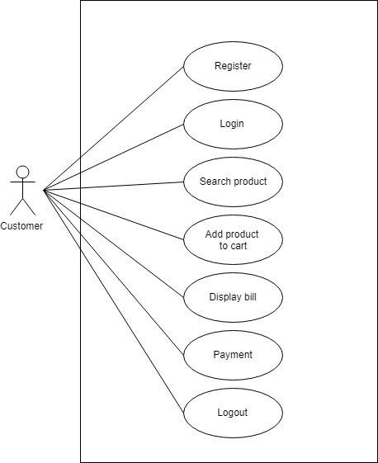

**7.2 Sequence Diagram:**

